Basic Second script:
===================
- #!/bin/bash
- pwd
- ls
- whoami
- date
- cal
- touch a b c
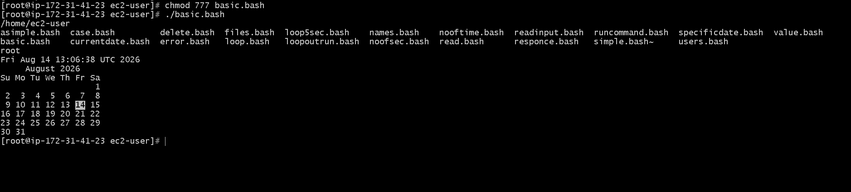

Basic Administration Tasks:
===========================
top
df -h
free -m
uptime
iostat
top get stucks because that will conitnously montior.
use top | head –12
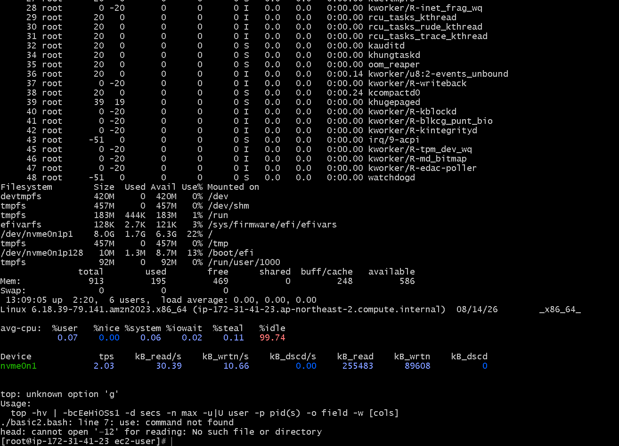

Defining Variables:
===================
- #!/bin/bash
- #Define Variables
- p=pwd
- l=ls
- wi=whoami
- d=date
- c='cal 2023'
- echo Run Variables tasks
- echo
- $p
- $l
- $wi
- $d
$c
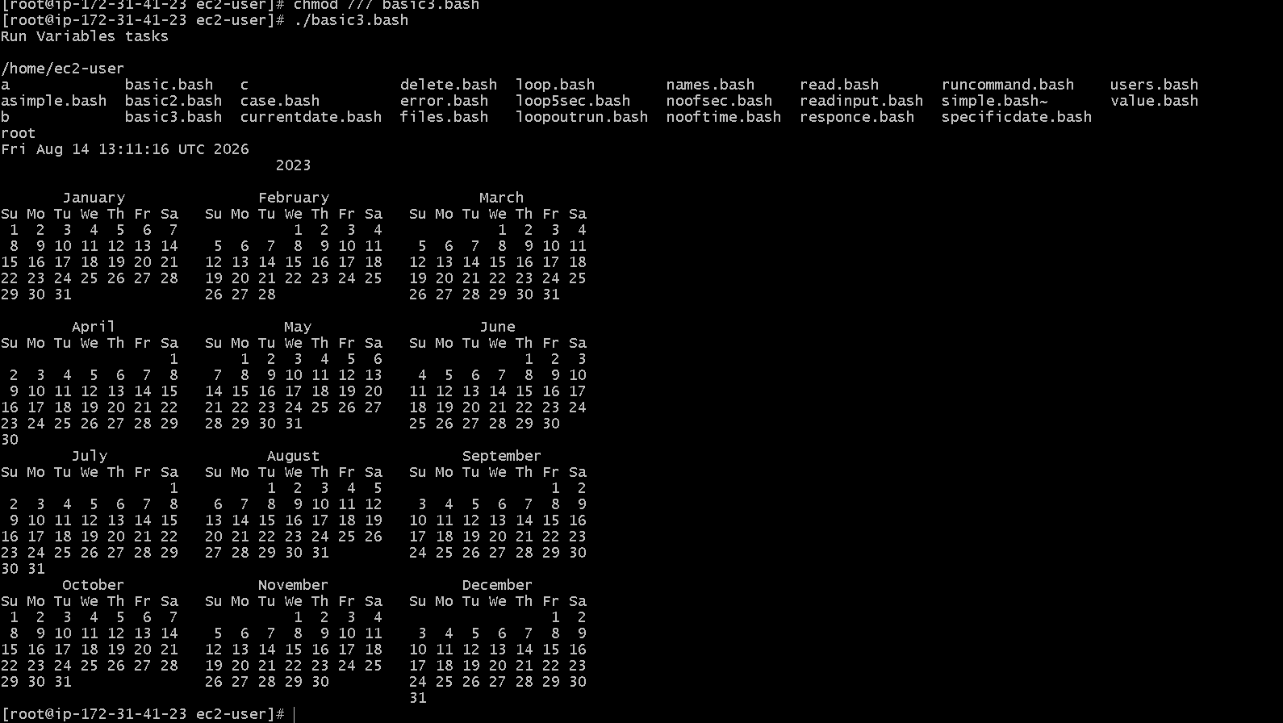

Input/Output script:
==================
- read --> To take command from user
- echo --> to print the output
- Ex1:
- #!/bin/bash
- echo Hello, my name is karthik
- echo
- echo what is your name?
- read name
- echo
- echo Hello $name
- echo
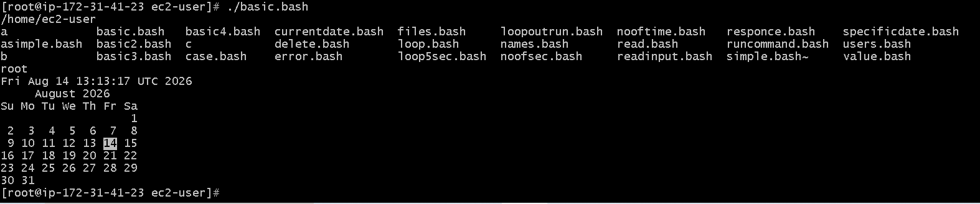

Input/Output script:
==================
- #!/bin/bash
- #we need to use the ticks if you want to use this in echo or else not required
- a=`hostname`
- echo Hello, my name is $a
- echo
- echo what is your name?
- read b
- echo
- echo Hello $b
- echo
- If i will change the a=`hostname` as the a= hostname it will does not display the ip i will
- display Hello , my name is hostname

